CS 305 Project One Template

Document Revision History

Version | Date | Author | Comments
1.0 | 1/21/2026 | Ethan | vulnerability assessment report

Client



Instructions
Submit this completed vulnerability assessment report. Replace the bracketed text with the relevant information. In this report, identify your security vulnerability findings and recommend the next steps to remedy the issues you have found.

- Respond to the five steps outlined below and include your findings.
- Respond using your own words. You may also include images or supporting materials. If you include them, make certain to insert them in the relevant locations in the document.
- Refer to the Project One Guidelines and Rubric for more detailed instructions about each section of the template.

Developer
Ethan Abdullah

1. Interpreting Client Needs
Determine your client’s needs and potential threats and attacks associated with the company’s application and software security requirements. Consider the following questions regarding how companies protect against external threats based on the scenario information:

- What is the value of secure communications to the company?
It is very high. Financial data such as account numbers, balances, and personal identifiers must be transmitted securely using HTTPS/TLS.
- Are there any international transactions that the company produces?
Yes. Artemis Financial operates globally, so secure communications must accommodate cross border data transfer laws.
- Are there governmental restrictions on secure communications to consider?
Regulations like GDPR, CCPA, and financial compliance laws require proper encryption, access control, and secure storage.
- What external threats might be present now and in the immediate future?
SQL injection, remote code execution, insecure deserialization, unauthorized API access, and exploitation of vulnerable third-party libraries. Threats can come from hackers, ransomware, and even insider threats.
- What modernization requirements must be considered, such as the role of open-source libraries and evolving web application technologies?
several things must be considered here, which are:
      - The use of open-source libraries introduces potential vulnerabilities (like in the dependency-check report).
      - Web technologies (Spring Boot, embedded Tomcat) must be updated to mitigate known CVEs.
      - Secure API design and input validation are required for modern RESTful applications.

2. Areas of Security

An architecture review is necessary to understand the application’s design, data flow, and security boundaries. Input validation is very important to prevent SQL injection and to ensure safe processing of user input. All REST API endpoints must be secure, which includes implementing proper authentication and rate limiting. Cryptography should be utilized for secure communication and the storage of sensitive data; vulnerabilities were identified in libraries such as BouncyCastle. A server is also essential for the secure handling of requests and responses, particularly for global transactions. It is also important to maintain high code quality, as improper exception handling (such as using e.printStackTrace()) can very easily expose sensitive information. Additionally, poor encapsulation in classes like Customer poses risks, as default access modifiers expose sensitive fields.

3. Manual Review
Continue working through the vulnerability assessment process flow diagram. Identify all vulnerabilities in the code base by manually inspecting the code.

- CRUDController.java has an SQL Injection risk in DocData.read_document() due to string concatenation. This means attackers can manipulate input to execute arbitrary SQL.
- DocData.java has hardcoded database credentials (root/root). This exposes sensitive data. Additionally, SQL connection is not in try-with-resources, which may leak connections.
- customer.Java is missing access modifiers, which will naturally break encapsulation.
- The controllers do not have authentication or authorization for API endpoints. Anyone can call APIs without credentials.
- There is an absence of logging or monitoring features, and there is no tracking of events such as unsuccessful login attempts or server errors. In the absence of monitoring, harmful activities or system issues will remain completely undetected.
- In customer.java, deposit amounts can be negative or too large, risking incorrect balances.
- In general, the use of outdated third-party libraries, including Spring, Tomcat, Jackson, and SnakeYAML, introduces additional security risks.

4. Static Testing
Run a dependency check on Artemis Financial’s software application to identify all security vulnerabilities in the code. Record the output from the dependency-check report. Include the following items:

- The names or vulnerability codes of the known vulnerabilities
- A brief description and recommended solutions provided by the dependency-check report
- Any attribution that documents how this vulnerability has been identified or documented previously

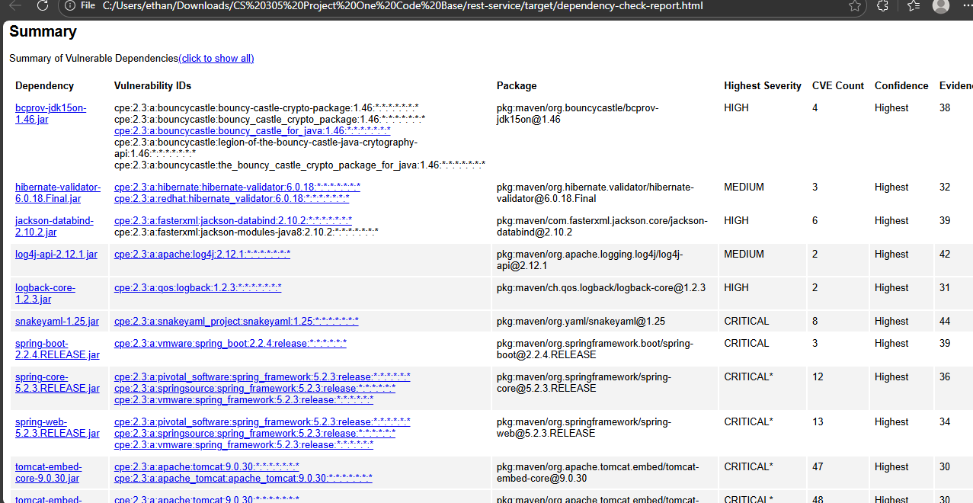

dependency | severity level | CVE count | main description | recommended fix
snakeyaml-1.25.jar | CRITICAL | 8 | remote code execution vulnerabilities due to unsafe YAML deserialization. | This needs to be upgraded to the latest version.
spring-boot-2.2.4.RELEASE.jar | CRITICAL | 3 | There are multiple vulnerabilities here, including RCE and information disclosure. | Upgrade to the latest stable release.
spring-core-5.2.3.RELEASE.jar | CRITICAL | 12 | Several known exploited vulnerabilities in Spring Core affecting deserialization and RCE. | Upgrade to Spring Core 5.3.x or later.
spring-web-5.2.3.RELEASE.jar | CRITICAL | 13 | Vulnerabilities in Spring Web allowing remote attacks and deserialization issues. | Upgrade to Spring Web 5.3.x or later.
tomcat-embed-core-9.0.30.jar | CRITICAL | 47 | Multiple critical vulnerabilities in embedded Tomcat affecting web requests and servlet handling. | Upgrade to Tomcat 9.0.80 or the latest stable release.
tomcat-embed-websocket-9.0.30.jar | CRITICAL | 48 | Vulnerabilities affecting embedded WebSocket handling, allowing remote code execution. | Upgrade to Tomcat 9.0.80 or latest stable release.
bcprov-jdk15on-1.46.jar | HIGH | 4 | Known cryptography vulnerabilities in older Bouncy Castle versions. | Upgrade to Bouncy Castle 1.70 or later.
jackson-databind-2.10.2.jar | HIGH | 6 | Remote code execution vulnerabilities due to unsafe deserialization of JSON. | Upgrade to Jackson Databind 2.15.x or later.
logback-core-1.2.3.jar | HIGH | 2 | Vulnerabilities in logging that may allow configuration injection or denial of service. | Upgrade to Logback 1.4.x or later.
hibernate-validator-6.0.18.Final.jar | MEDIUM | 3 | Validation-related vulnerabilities that may allow bypass of input checks. | Upgrade to Hibernate Validator 6.2.x or later.
log4j-api-2.12.1.jar | MEDIUM | 2 | Logging vulnerabilities including potential remote code execution (CVE-2021-44228 is not currently present here but older issues do exist). | Upgrade to Log4j 2.17.x or later.

5. Mitigation Plan
Interpret the results from the manual review and static testing report. Then identify the steps to mitigate the identified security vulnerabilities for Artemis Financial’s software application.

After conducting a manual review and static testing, several recommendations have been established to enhance application security and stability. First, it’s important to upgrade any vulnerable dependencies to secure versions. Additionally, database connections should be secured by removing hardcoded credentials and instead utilizing environment variables or secure vaults. It's also important to sanitize and validate all user inputs, especially in CRUDController, to prevent potential vulnerabilities. Implementing proper API security measures, such as OAuth2 and JWT (JSON Web Tokens), will further safeguard the application. Furthermore, ensure that all class fields are private, using getters and setters where necessary. For error handling, log errors securely to avoid exposing stack traces to users. To prevent database connection leaks, use the try-with-resources statement when managing database connections. Lastly, after deploying the updated libraries, it is important to track access logs and monitor for any unusual activity. Following these practices will significantly improve the security and integrity of the application.

